Amazon Candidate Expense Form
Thank you for taking the time to interview with us – we hope that your experience was a good one. We have a few instructions on submitting your expenses so please take a couple of minutes to review below.
Amazon will reimburse you for your local transportation and incidental interview expenses and you will be paid by direct deposit for reimbursement (more info listed below). Please note that we ask you to allow 3-4 weeks for your reimbursement to be received.
After you have completed this expense form, please email, along with scanned receipts, to candidate-expense@amazon.com for
processing. Please copy your recruiting coordinator on your submission for most efficient processing. If you are unable to submit this form by email then please fax it, along with attached receipts, to 702-478-3737.
If you have any questions about your expenses, please contact your Recruiting Coordinator or email expense-reports@amazon.com.
The Candidate Expense Form is required to reimburse your expenses. Failure to submit a completed form will result in a delay in processing or non-payment. Please ensure your expense reimbursement submission is less than 10MB. Files larger than 10MB will not be received by the expense report team and you will not be reimbursed for your expenses. Please also ensure that this form is submitted as a single file.
- You will receive reimbursement by direct deposit; a US bank account is required.
- A bank confirmation letter, bank statement, or voided check are required to confirm routing and account numbers. Please upload one of these items, or a screenshot of your banking details, for verification so that payment can be provided without issue.
- Please photocopy as many of your receipts as possible onto a single page.
- Please ensure that your name, address, zip code, email and bank information are typed or printed clearly on the report. Missing information will result in a delay in your reimbursement processing.
- Please list any taxi or shuttle charges under the ‘Transportation’ column and not the ‘Miscellaneous’ column.
- Amazon will not reimburse any alcohol/mini bar charges, dry cleaning, health club fees, video rentals, kennel fees, museum/concert tickets, loss of personal property, or any sightseeing expenses. Car rental expenses will only be reimbursed if reservations have been made through the Amazon Travel Team. Please contact your Recruiting Coordinator if you have any travel-related questions.
- Please remember to keep all receipts as these are required along with the completed expense form in order to receive reimbursement.
- All required fields, identified by an asterisk*, must be completely filled out in order for your expenses to be reimbursed.
- Expense forms should be submitted within 90 days of your interview, any forms received after 90 days may not be processed. All forms should be submitted in typed format. Handwritten forms will not be accepted.
SECTION A – GENERAL CANDIDATE INFORMATION

Name  Address line 1 Address line 2 City/State/Province Zip/Postal code Phone  Email |  | Please scan your form and receipts and email both to:  candidate-expense@amazon.com  *Please confirm that your personal information is correct. Incorrect information may delay processing of your reimbursement.

Page 1 of 3 v1.7 – Revised 7/6/18


Amazon Candidate Expense Form
SECTION B – DIRECT DEPOSIT

Direct Deposit
Bank Name*
Bank Address
Name on Account*
Account Number*
Routing Number (must be 9 digits)*
Account Type* (checking or savings)

I hereby authorize Amazon to follow the direct deposit instructions indicated above. This request is to remain in effect until changed by me in writing by submitting a new Direct Deposit form, or until Amazon has received written notification from me of its termination (emailing ‘expense-reports@amazon.com is sufficient). I also authorize Amazon to withdraw any funds that are erroneously deposited into my account due to an error on Amazon’s part without giving me prior notice.
__________________________________________________________________________________________________
Candidate Signature* (Digital signature above is preferred) Date*
It will be the Candidate’s responsibility to inform the Accounts Payable Department (via expense-reports@amazon.com) should any information on this form require change.
Please attach a voided check or bank statement below:
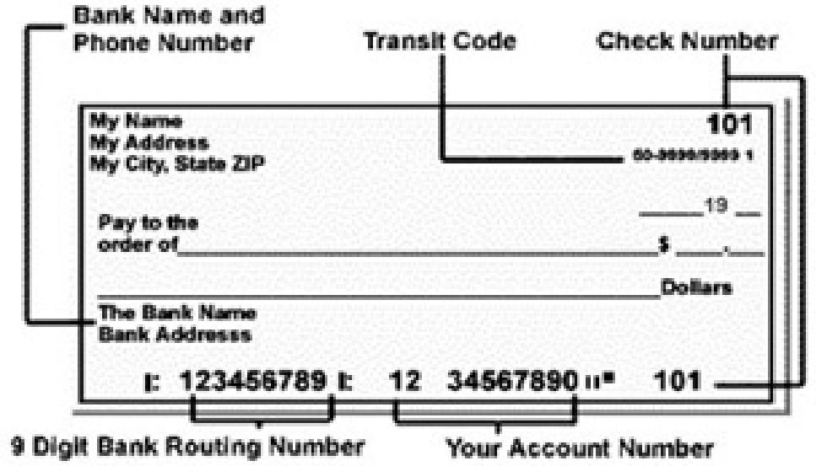

Page 2 of 3 v1.7 – Revised 7/6/18

Amazon Candidate Expense Form

SECTION C – CANDIDATE EXPENSES
Amazon will not reimburse: Alcohol/hotel mini bar charges, dry cleaning, health club fees, video rentals, kennel fees, museum/concert tickets, loss of personal property or any sightseeing expenses will not be reimbursed. Amazon will not reimburse
above the daily limits. The Miscellaneous column should only be used in emergencies or exceptional circumstances. This will be reviewed on a case by case basis. In the rare case Amazon did not prebook/pay for your hotel and you were charged personally, make sure to include the receipt/CC statement highlighting the charge and add this in the Miscellaneous column. Failure to submit proof of
payment will result in a delay or nonpayment.

Amazon will reimburse the following expenses: A maximum of $65 per day for meals. Up to $100 per day for reasonable local ground transportation (taxi, bus). Up to $25 per day for parking charges at your home airport. Up to $20 per day for reasonable phone/internet charges. To be reimbursed for mileage of your personal vehicle please list the total miles traveled and our Accounting Team will convert the mileage at the current government regulated rate, which can be found at http://www.irs.gov, keyword: mileage. All expenses will be subject to review by the Recruiting Department.

Expense Date | Description of Expense  *all expenses must have receipt | Meals  ($65/day max) | Transportation  ($100/day max) | Miscellaneous  ($45/day max)  And hotel if applicable
 | Subtotals
 |  |  | Grand Total

Amazon.com/Careers
Work hard. Have fun. Make History.

Internal Use Only: Required Entry by RC

Recruiting Coordinator: | Irene Chen
L6+ Recruiting Manager: | Leila Langlois
Co. Code/Loc. Code/Cost Center | 2D/1000/4002
Approved Dates/# of Days | 11/13/2018-11/15/2018

After completing this form, please send it to candidate-expense@amazon.com and copy your recruiting coordinator. Please ensure
that this form is submitted as a single file.
Thank you for your time.
Page 3 of 3 v1.7 – Revised 7/6/18
 | Thank you for your time.  Page 3 of 3 v1.7 – Revised 7/6/18

